Pac-Man

In this project you will create a Pac-Man game in Scratch that is able to learn from how you play.

You won’t give it instructions for how to play, or tell it what the objective or rules of the game are.

Instead, you’ll show it examples of you playing the game.

Creative Commons LicenceThis project worksheet is licensed under a Creative Commons Attribution Non-Commercial Share-Alike License

http://creativecommons.org/licenses/by-nc-sa/4.0/

1. Go to <https://machinelearningforkids.co.uk/scratch> in a browser.
2. Open the **Pac-Man** template for this project.   
   *Click on the* ***Project templates*** *menu   
   Then find the* ***Pac-Man*** *tile in the list and click on it*   
   A screenshot of a computer

   Description automatically generated
3. Click the **full-screen** button, and then click the **Green Flag**  
   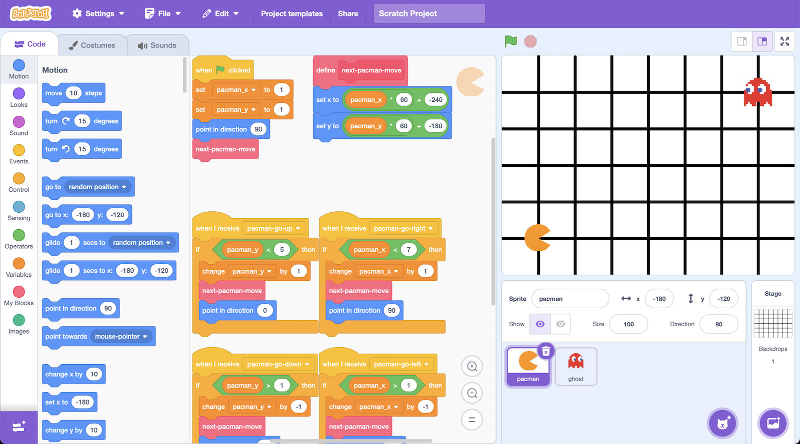
4. Play a few games of Pac-Man  
   *You control Pac-Man, and have to avoid the ghost as long as you can.   
   Use the arrow keys to control Pac-Man’s next move.*   
   *Click the green flag to start a new game.*
5. Try to come up with a plan for how Pac-Man can avoid the ghost

Representing Pac-Man in Scratch

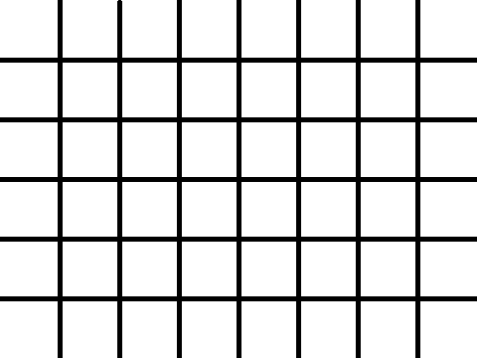

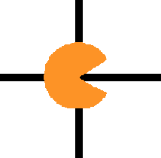

At each turn, each character has to choose between four moves:

up, down, left, right.

(There are no diagonal moves.)

down

left

right

up

The game board is a graph.

Pac-Man and the ghost can only travel along lines.

The location of each character is stored as:

* an x-value (a number from 1 to 7)

* a y-value (a number from 1 to 5)

For example, the ghost on the left is at:

X = 5

Y = 2

y values

1

2

3

4

5

x values

7

6

5

4

1

2

3

**What are you going to do?**

You’re going to train Pac-Man to avoid the ghost. You’ll do this by showing it examples of how you play the game.

Imagine the board looks like this:

Imagine you decide to go down:

Imagine the board looks like this:

Imagine you decide to go up:

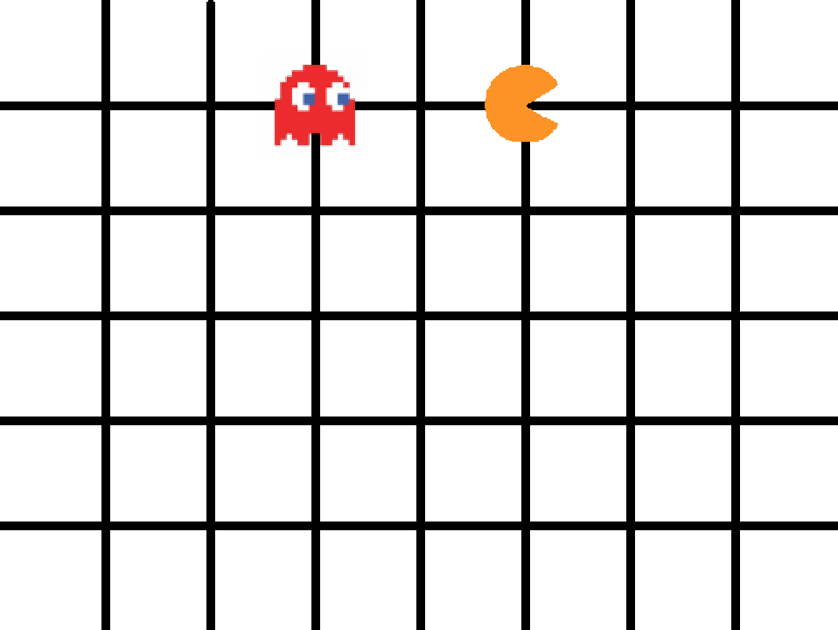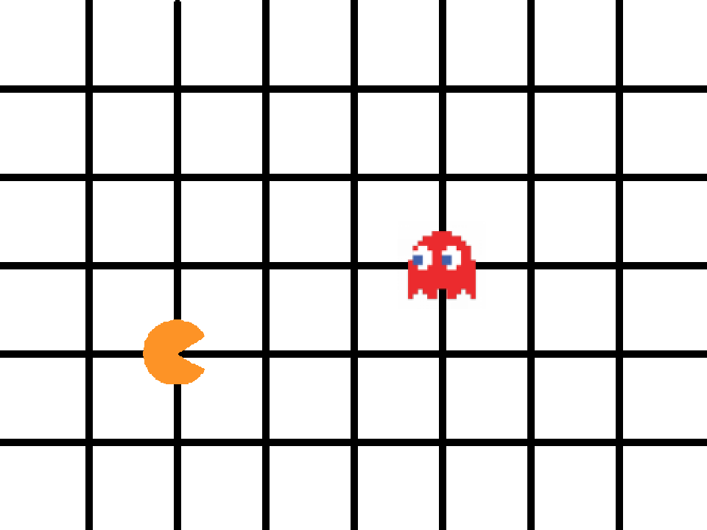

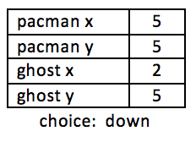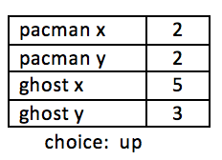

The computer will learn from the decisions that you make when you play the game.

If you make moves that avoid the ghost for a long time, the computer should learn how to avoid the ghost!

1. Close the Scratch window.
2. Go to <https://machinelearningforkids.co.uk/> in a web browser
3. Click on “**Get started**”
4. Click on “**Log In**” and type in your username and password  
   *If you don’t have a username, ask your teacher or group leader to create one for you.  
   If you can’t remember your username or password, ask your teacher or group leader to reset it for you.*
5. Click on “**Projects**” on the top menu bar
6. Click on the **“+ Add a new project**” button.
7. Name your project “pacman” and set it to learn how to recognise “**numbers**”  
   A screenshot of a computer

   Description automatically generated
8. Click “**Add a value**” and name a value “pacman x” and make it a “number”.  
   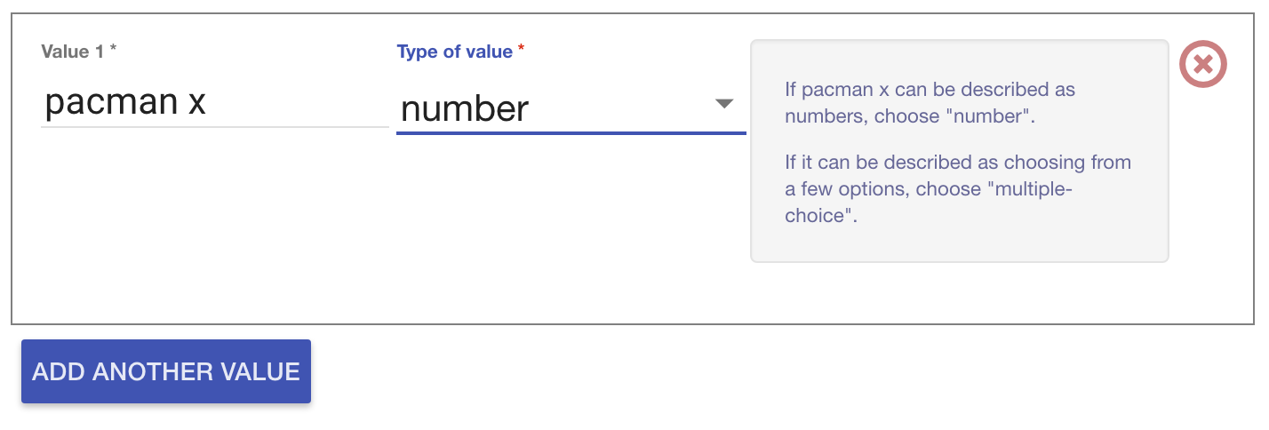
9. Click “**Add another value**” again and repeat to add values for the other three positions: “pacman y”, “ghost x”, “ghost y”
10. Click **Create**.   
    A screenshot of a computer

    Description automatically generated
11. You should see “**pacman**” in the list of your projects. Click on it.  
    A screenshot of a computer

    Description automatically generated
12. Click the “**Train**” button  
    A screenshot of a computer

    Description automatically generated
13. Click “**+ Add new label**” and create a label called “left”  
    *Examples of the locations of the Pac-Man and ghost when you go left will go in this bucket.*   
    A screenshot of a computer

    Description automatically generated

1. Click “**+ Add new label**” again and create labels for the other three moves in the game.  
   *“right”, “up”, “down”*A screenshot of a computer screen

   Description automatically generated
2. Click the “**< Back to project**” link
3. Click the “**Make**” button then click the “**Scratch 3**” button
4. Click the **straight into Scratch** button  
   *It will warn you that you haven’t trained the computer yet.   
   That’s okay, as you’ll use Scratch to collect the training examples.   
   A screenshot of a computer

   Description automatically generated*
5. You should see new blocks in the toolbox from your “pacman” project.  
   A screenshot of a computer

   Description automatically generated
6. Open the Pac-Man template project again.  
   *Click* ***Project templates*** *and then click on* ***Pac-Man***
7. Click on the **Stage** and find the “when green flag clicked” script that sets the “left”, “right”, “up”, “down” variables  
   A screenshot of a computer

   Description automatically generated
8. Modify the script to use your new blocks from the pacman project  
   A screenshot of a computer screen

   Description automatically generated
9. Find the custom block “pacman-decision”  
   A screenshot of a computer

   Description automatically generated
10. Update the “**pacman-decision**” block to add every move you make to your machine-learning training data  
    A screenshot of a computer

    Description automatically generated
11. Train the computer by playing the game!   
    *Click on full-screen again, and then the Green Flag.   
    Play a few games of Pac-Man, doing your best to avoid the ghost.   
    The better you play, the better moves the computer has to learn from.*
12. Save your project  
    *Click* ***File*** *->* ***Save to your computer*** *Name the file “pacman learn” to remind yourself that this version of the project is the one to train Pac-Man.*
13. Go back to the training tool window
14. Click the “**< Back to project**” link, then click the “**Train**” button  
    *You should see the training examples you collected by playing Pac-Man.*A screenshot of a computer

    Description automatically generated

**What have you done so far?**

You’re teaching a computer to play Pac-Man.

You updated a Pac-Man game so it collects examples of how you play and adds them to a set of examples.

You’ll use those examples to train a machine learning “model”.

1. Click the “**< Back to project**” link
2. Click the “**Learn & Test**” button
3. Click the “**Train new machine learning model**” button  
   A screenshot of a computer program

   Description automatically generated
4. Go back to the Scratch 3 window.   
   *If you accidentally closed it, you can get back to it by doing this:  
   * Click the “****< Back to project****” link  
   * Click the “****Make****” button  
   * Click the “****Scratch 3****” button  
   * Click the “****Open in Scratch 3****” button  
   * Open the Scratch file you saved before (“****File****” -> “****Load from your computer****”)*
5. Click on the Stage  
   A screenshot of a computer

   Description automatically generated
6. Delete these key-pressed scripts (because it’s the computer’s turn!)  
   *(Delete a script by right-clicking on it and choose “Delete Block”)  
   These are the scripts you don’t need any more. Delete all of these.   
   A screenshot of a cell phone

   Description automatically generated*
7. Modify the custom “**pacman-decision**” block  
   *Instead of learning from what you are doing, now you want it to use your machine learning model  
   A logo with orange and blue text

   Description automatically generated with medium confidence*
8. Modify the “**Click Green Flag**” script to remove “wait 1 second”. *You want the script to end up looking like this:  
   A screenshot of a computer

   Description automatically generated*
9. Save your project  
   *Click* ***File*** *->* ***Save to your computer*** *Name the file “pacman play” to remind yourself that this version of the project is where the computer controls Pac-Man.*
10. Test the computer!  
    *Click on full-screen again, and then the Green Flag.   
    Watch the Pac-Man you’ve trained try to avoid the ghost.*
11. Open the training project “**pacman learn**”.  
    *Make sure you save your “pacman play” project first!  
    Click* ***File*** *->* ***Load from your computer***
12. Train the computer some more by playing a few more games.
13. Go back to the training tool
14. Go back to the “Learn & Test” page  
    *Click the “****< Back to project****” link, and then click “****Learn & Test****”*
15. Click the “**Train new machine learning model**” button again
16. Switch back to the Scratch window.   
    *If you accidentally closed it, you can get back to it by doing this:  
    * Click the “****< Back to project****” link  
    * Click the “****Make****” button  
    * Click the “****Scratch 3****” button  
    * Click the “****Open in Scratch 3****” button*
17. Open the testing project “**pacman play**”  
    *Click* ***File*** *->* ***Load from your computer***
18. Test the computer again  
    *Did the computer do any better after more training?*

**What have you done?**

You’ve trained a computer to play Pac-Man.

You didn’t need to describe the rules to the computer.

You didn’t tell it that it should try to avoid the ghost.

You didn’t describe the boundaries of the board.

(The rules are in the Scratch game, but that doesn’t count – they weren’t used to make Pac-Man’s decision of where to go next).

Instead, you showed it how you play, by collecting examples of decisions that you made when you play.

**Tips**

**Getting stuck in a loop**

Sometimes the computer can get lucky, and find a circular route around the board that gets into a never-ending loop.

When this happens, Pac-Man will never lose!

You can press the red stop button if you need to stop though.

**Don’t be kind!**

You might be tempted to go easy on the ghost when you’re playing against it.

Don’t. It is learning from the way that you play. If you don’t play well, it can’t learn how to play well.

If you want it to get better quickly, **play as well as you can**.

**Keep training**

The more examples the computer has to learn from, the better it will get. If you have time, play a lot of games and train a new model again.

**Ideas and Extensions**

Now that you’ve finished, why not give one of these ideas a try?

Or come up with one of your own?

**Add another ghost**

The game is beatable with only one ghost – Pac-Man can just carry on avoiding the ghost forever.

But with a second ghost chasing after Pac-Man, it will get really hard.

**Change the game board**

Try making the game board bigger.

Or add obstacles that Pac-Man and the ghost will need to go around.

**Make your own game**

This doesn’t only work with Pac-Man.

Why not make your own game in Scratch, and then train a machine learning model to be able to play it?